Exercise
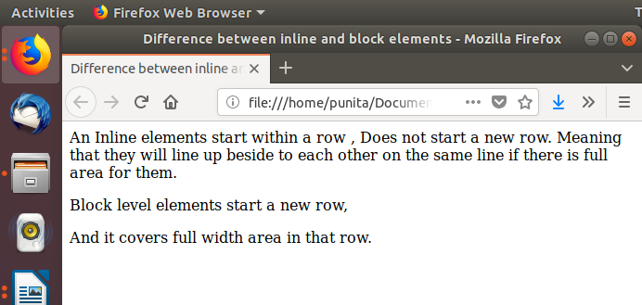
1.How are inline and block elements different from each other?

2.Explain the difference between visibility:hidden and display:none
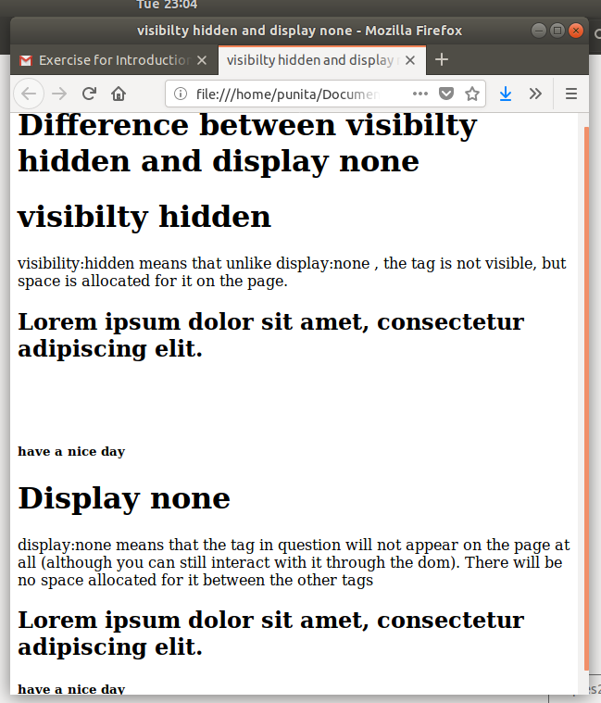

3. Explain the clear and float properties.
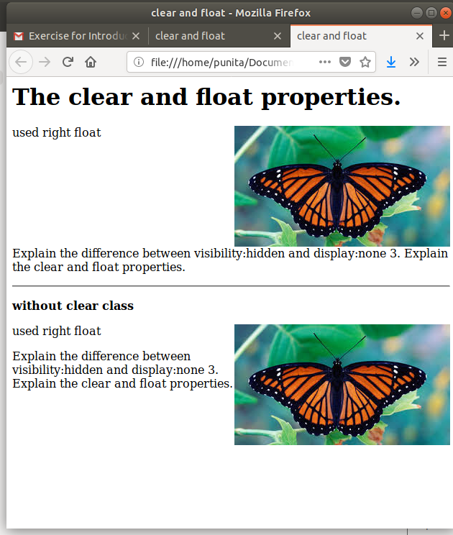

Ques4:. explain difference between absolute, relative,fixed and static.
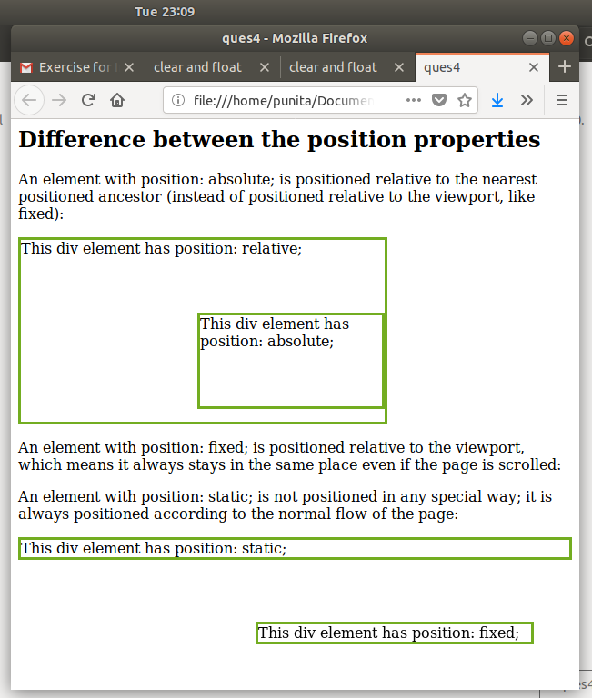

Ques5:Write the HTML code to create a table in which there are 4 columns( ID , Employee Name, Designation, Department) and at least 6 rows. Also do some styling to it.
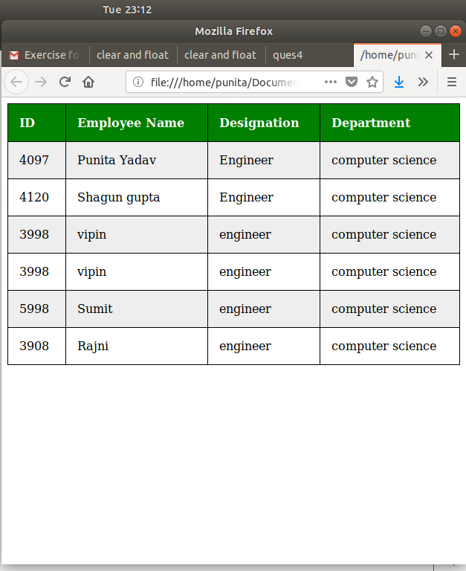

Ques 6:Why do we use meta tags?
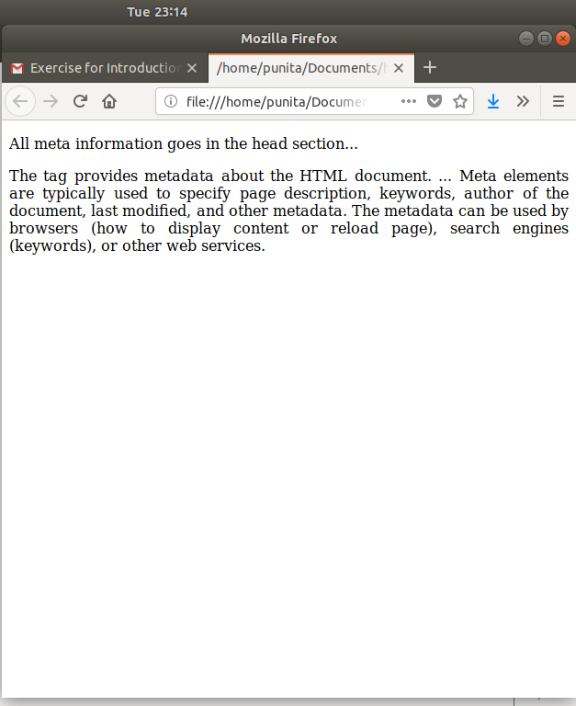

Ques 7:Explain box model.
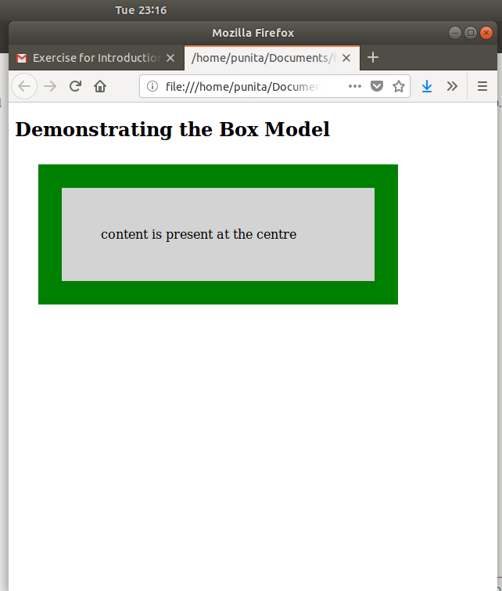

Ques 8:What are the different types of CSS Selectors?
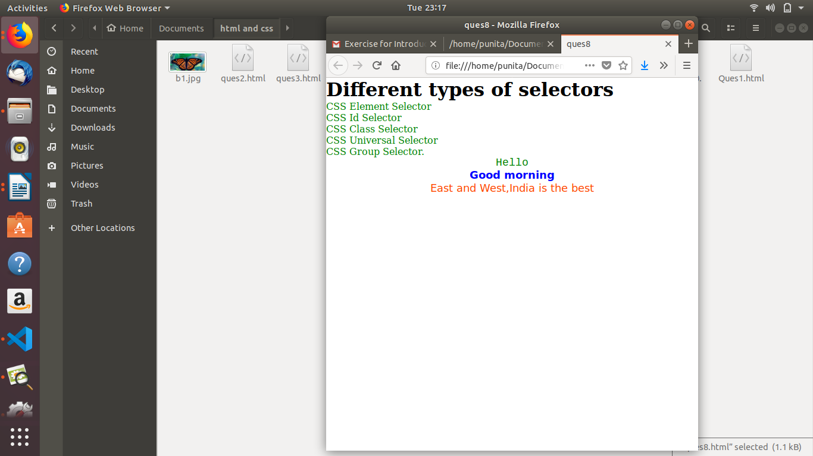

Ques 9 Define Doctype.

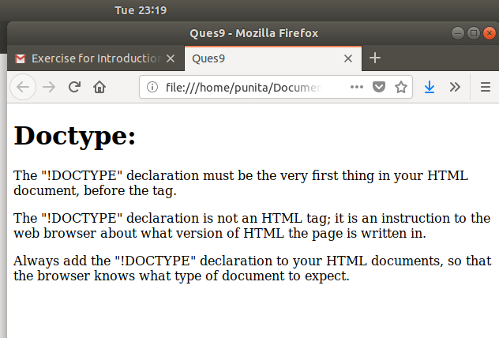

Ques 10:Explain 5 HTML5 semantic tags.

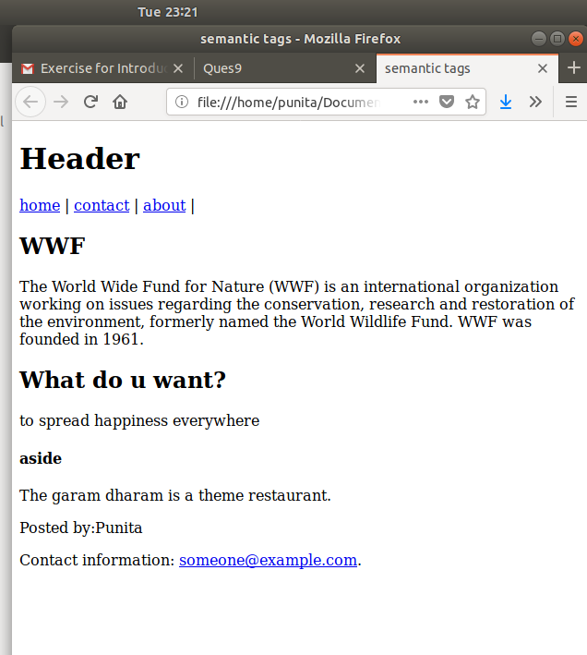

Ques11:Create HTML for web-page.jpg
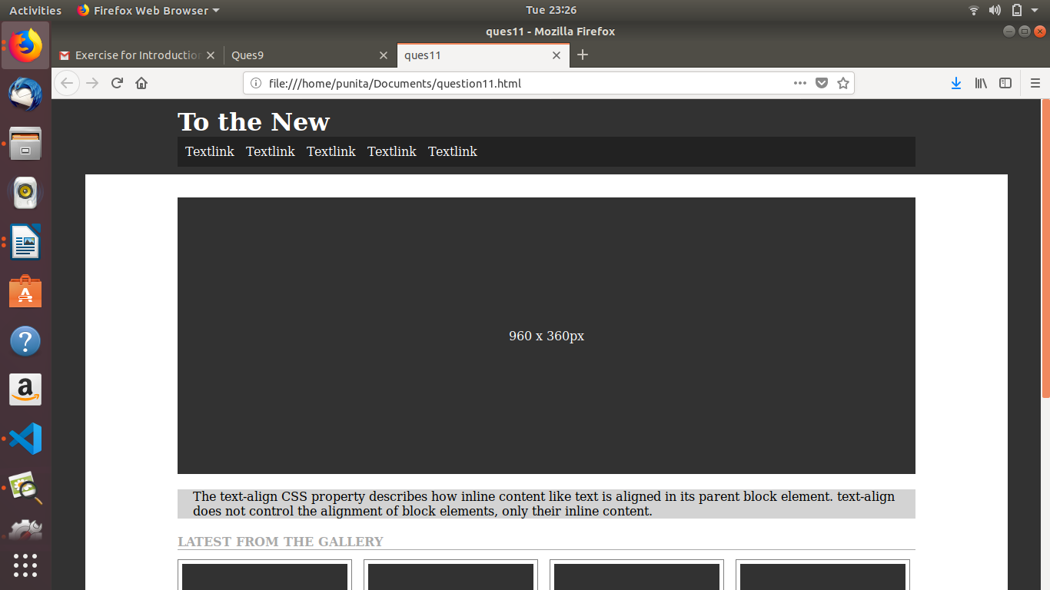

Ques12:Create HTML for form.png
